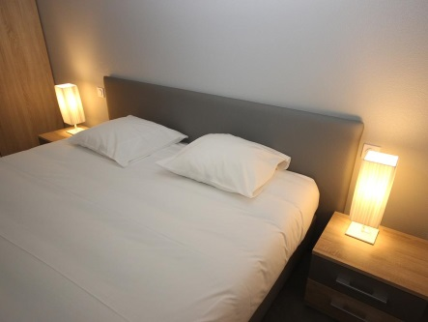

CHAMBRES
GOLD BEACH HOTEL
Asnelles-sur-mer

ROOMS N° | FLOORS | PAX MIN | PAX MAX | NAMES
2 | ground floor | 1 | 3
3 | ground floor | 1 | 3
4 | ground floor | 1 | 3
5 | ground floor | 1 | 3
6 | ground floor | 1 | 3
7 | ground floor | 1 | 3
8 | ground floor | 1 | 3
9 | ground floor | 1 | 3
10 | ground floor | 1 | 3
11 | ground floor | 1 | 3
12 | ground floor | 1 | 3
13 | ground floor | 1 | 3
14 | ground floor | 1 | 3
15 | ground floor | 1 | 3
ROOMS N° | FLOORS | PAX MIN | PAX MAX | NAMES
16 | ground floor | 1 | 3
17 | ground floor | 1 | 3
18 | ground floor | 1 | 3
19 | ground floor | 1 | 3
20 | ground floor | 1 | 3
21 | ground floor | 1 | 3
22 | ground floor | 1 | 3
23 | ground floor | 1 | 3
24 | ground floor | 1 | 3
25 | 1rst floor | 5 | 5
26 | 1rst floor | 2 | 5
27 | 1rst floor | 2 | 5
28 | 1rst floor | 6 | 6
29 | 1rst floor | 5 | 6
30 | 1rst floor | 2 | 5
ROOMS N° | FLOORS | PAX MIN | PAX MAX | NAMES
31 | 1rst floor | 2 | 5
32 | 1rst floor | 2 | 5
33 | 1rst floor | 2 | 5
34 | 1rst floor | 2 | 5
35 | 1rst floor | 2 | 5
36 | 1rst floor | 2 | 5
37 | 1rst floor | 2 | 5
38 | 1rst floor | 2 | 5
39 | 1rst floor | 2 | 5
0 | 1rst floor | 5 | 6
41 | 1rst floor | 5 | 6
ROOMS N° | FLOORS | PAX MIN | PAX MAX | NAMES
42 | 1rst floor | 5 | 6
43 | 1rst floor | 5 | 6
44 | 1rst floor | 5 | 6
45 | 1rst floor | 5 | 6
46 | 1rst floor | 5 | 6
47 | 1rst floor | 5 | 6
48 | 1rst floor | 5 | 6

